Validatable
Continuous Band Sealer

D 542 AVTSV

Equipped with:
Audion Touch Techware Version BS1.01_01

Technical
Specification Sheet
Rev.00
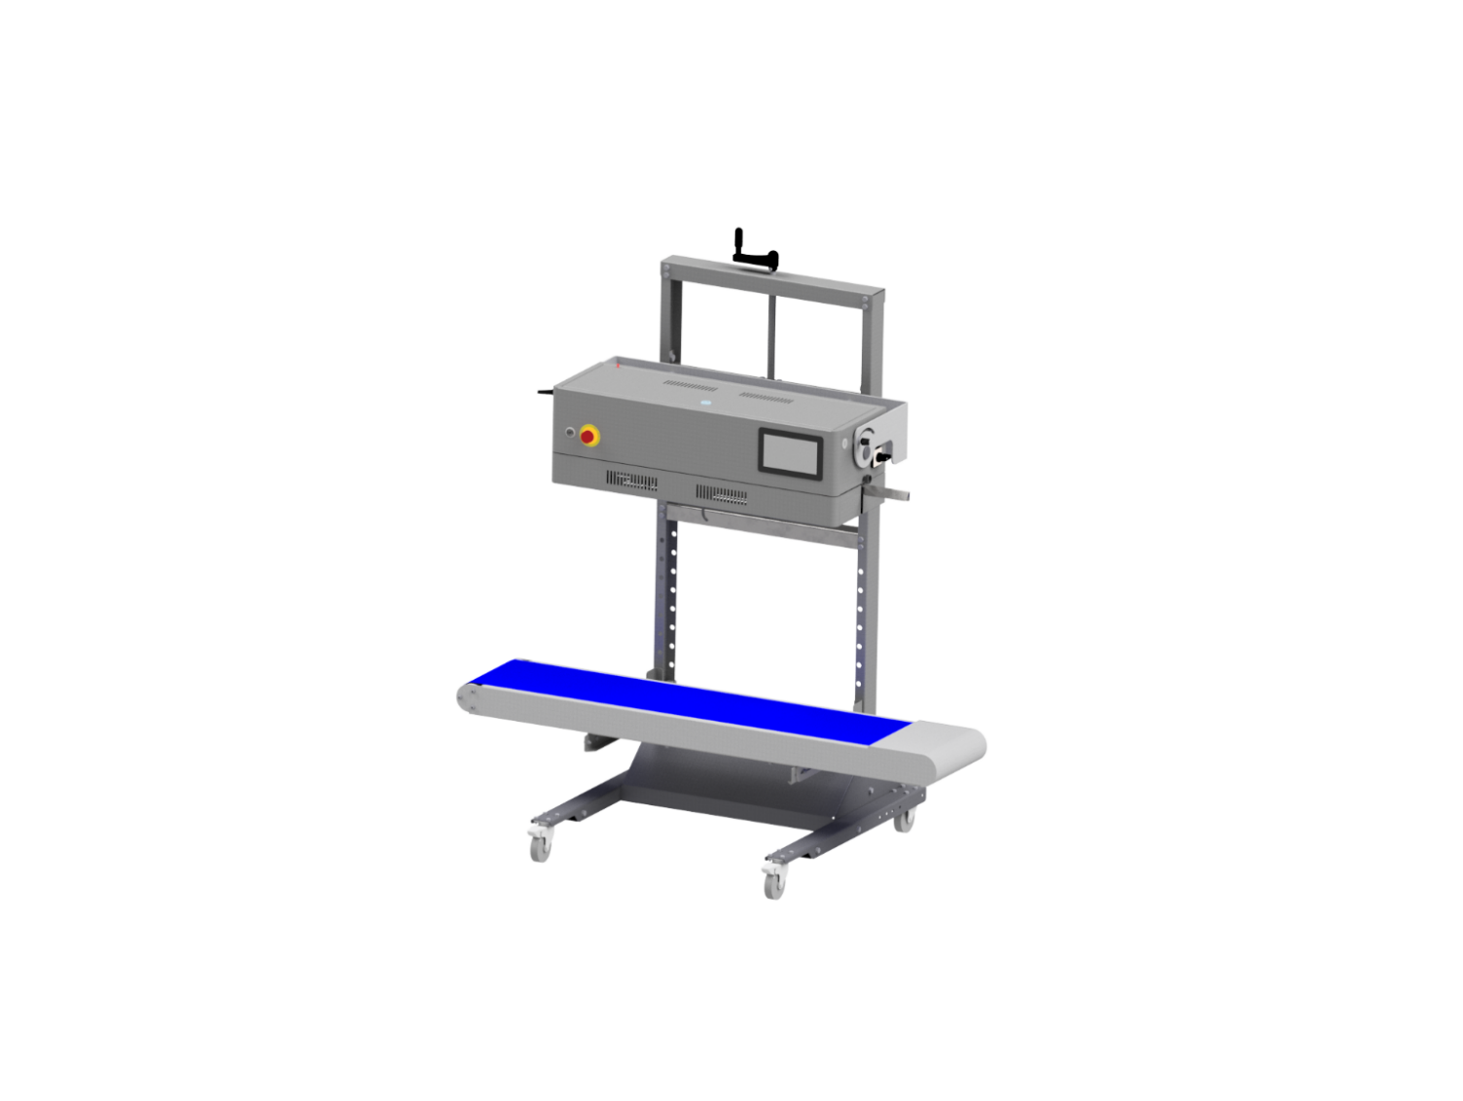 | 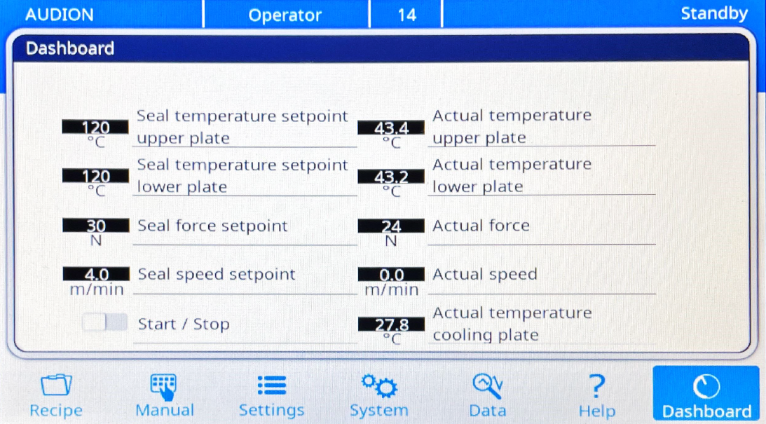

General specifications
Type of machine | Validatable vertical continuous band sealer
Model | D 542 AVTSV
Machine dimensions WxDxH | 1396 x 800 x 1588 mm (with conveyor belt)
Weight | 100 kg
Seal width | 10 mm
Seal system | Knurled seal
Bag material | Sealable pouches (PE, PP, laminate, paper bags, etc.)  Preformed sterile barrier system conforming ISO 11607-1, EN 868-5, EN868-9
Material thickness | 60 – 200 micron (depends on the type of material)
Bag length | 45 – 860 mm  (vertical sealing orientation with conveyor)
Max. carrying weight | 10 kg
Control system | Audion Touch Techware  Equipped with Audion Temperature Controller (ATC) + 7 inch touchscreen (ADC)
Data transfer | USB memory stick
Covering | Stainless steel
Sealing height adjustable  range (manual adjustment) | 757 - 1170 mm (vertical orientation)  917 - 1330 mm (horizontal orientation)
Conveyor belt height  adjustable range | 388 – 838 mm (in steps of 50 mm)
Conveyor belt width | 250 mm
Power supply | 230 V – 1ph – 50Hz
Power consumption | 1100 W
Noise level | < 85 dB(A)
IP rating | IP20
Applicable standards | 2006/42/EC, 2014/30/EU, 2011/65/EU+2015/863,  EN-ISO 12100:2010, EN-ISO 13732-1:2008, EN-ISO 13850:2015,  EN-ISO 14118:2018, EN-IEC 60204-1:2018,  EN-ISO 11607-2:2020, ISO/TS 16775:2021, EN 868-5:2018, DIN 58953-7:2020

Technical specifications
Recipe | Storage | 50 recipes
 | Recipe backup  (.bin file through USB stick) | Copy recipe to USB  Load recipe from USB
Process parameters | Seal temperature  Setting range  Tolerance range | 80 – 200 °C (max. 250 °C on request)  3 – 20 °C (default 5 °C)
 | Seal force  Setting range  Tolerance range | 5 – 80N (default 30 N)  +/- 0 – 50 N (default 10 N)
 | Seal speed  Setting range  Tolerance range | 1,0 – 10,0 m/min.  +/- 0,0 – 5,0 m/min. (default 0,5m/min.)
Adjustable parameters | Fine tuning for calibration | Seal temperature  Seal force
Validation functions | Parameter monitoring  (alarm stop) | Seal temperature  Seal force  Seal speed  Seal length
 | Data logging / batch record  (.csv file through USB stick) | Machine ID  User name  Recipe name  Batch ID  Parameter settings  Parameter tolerances | Alarm limits  Date/time  Seal ID  Parameters results  Pass/fail  Alarm code
System & functions | User administration (option) | User name  User levels | Login password  Logout time setting
 | User levels | Operator  Supervisor  Administrator | Service
 | Language | English  German  Netherlands | French  Italian
 | Alarm history | Date/time  Alarm code/descriptions
 | Counter | Bag counter (resettable)  Machine counter (non-resettable)

Data logging file
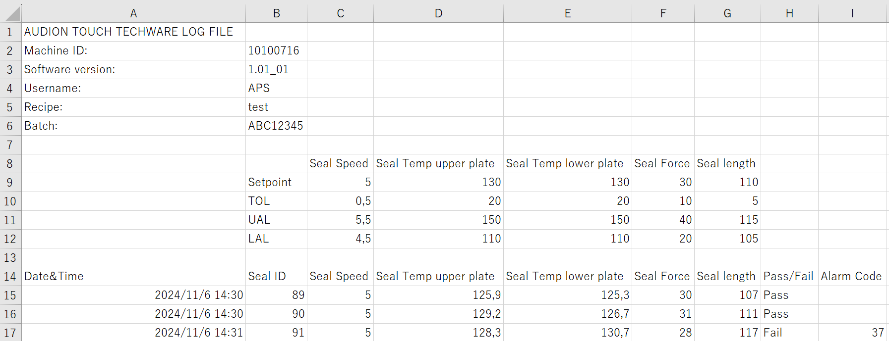

Machine dimensions
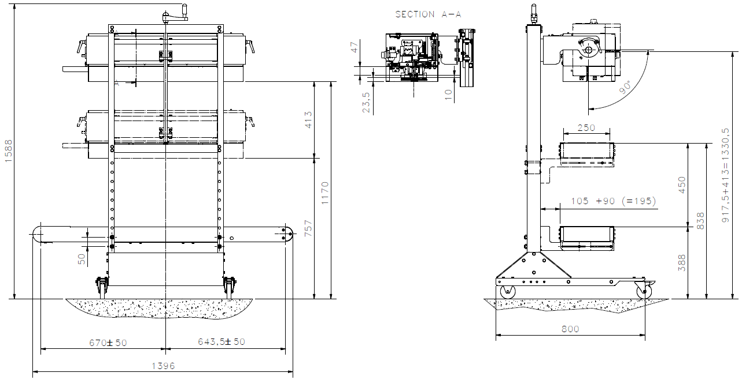

* The diagram includes the optional conveyor belt

Bag size range
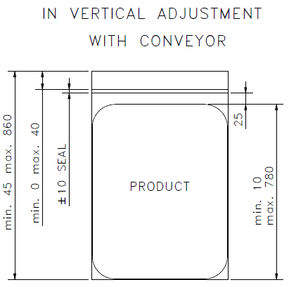 | In vertical sealing orientation with conveyor

Option | Descriptions
User administration | Access control with login ID and password
Label printer (ETO) | For printing tracing information on labels and apply on packaging  Label printer : CAB MACH2
Barcode scanner (ETO) | Quick recipe change by scanning a barcode  Scanner : Honeywell Voyager 1400g
Communication with external conveyor belt (ETO) | Output signal to external conveyor to synchronize with sealing belt

Accessories / Services | Codes | Descriptions
Parameter verification | ATM-R | Seal temperature verification set
 | AFMR | Seal force verification set
 | ASM | Seal speed verification set
Calibration |  | Audion factory calibration
IQ/OQ Check | IQ/OQ VAL | 1 x IQ check for 1 machine  > Operation training (max. 4 persons)  > Maintenance training (max. 4 persons)  OQ check for 1 type of bag  > Peel test for defining seal temperature  > Peel test with defined seal temperature  > Dye penetration test  > Seal check
 | OQC | Extra OQ check for each extra bag
Seal integrity test | SIT | Seal integrity test service  > Peel test  > Dye penetration test  > Seal check
 | APT 100 | Peel tester
 | ASC SHEET | Seal check sheet
 | ASC ROLL | Seal check sheet in roll
 | ASC INK-B | Blue ink for dye penetration test

Measuring instruments for parameter verification
Seal temperature  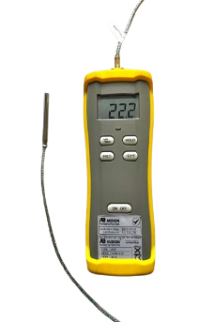  ATM-R | - Measurement range: -60°C to 350°C  - Thermocouple: NiCr-Ni Type K  - Diameter: 6 mm  - Resolution: 0,1°C (up to 199,9°C) / 1 °C (above 200°C)  - Accuracy display unit: 0.3% of reading + 1°C  - Measuring rate: 2,5 per second  - Minimum and maximum values readable  - Operating conditions: +5 ... 50 °C, 30 – 70% RH (non-condensing)  - Power supply: 9V battery  - Battery life: +/- 100 hours  - Dimensions: 63 (W) x 186mm (L) x 40mm (D)  - Weight: 350 grams
Seal force  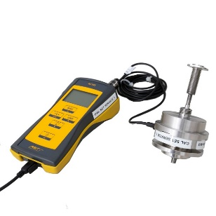  AFMR | - Measurement range: max. 2000 N  - Resolution: 0,1 N  - Accuracy class: 0,5 %  - Operating temperature range: -10 ... +50 °C  - Max. Overload: 120%  - Measuring rate: 50 per second  - Power supply: 3x AA batteries  - Battery life: +/- 40 hours  - Environmental protection: IP 54  - Dimensions: 82mm (W) x 162mm (L) x 54mm (D)  - Weight: 670 grams (excluding mounting tools)
Seal speed  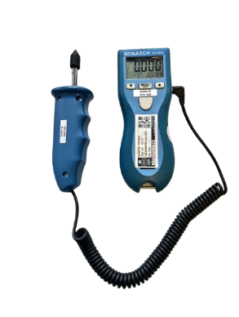  ASM | - Display: 5-digits, 5-alphanumeric LCD  - Range (Optical): 5 to 200,000 RPM (subject to ambient light intensity)  - Range (Contact): 0.5 to 20,000 RPM (also reads RPS and RPH)  - Accuracy (Optical): +/-0.01% of reading  - Accuracy (Contact): +/-0.05% of reading  - Totalizer: 1-999,990 (events or length)  - Resolution: 0.001 to 10 RPM (range dependent)  - Operating Range: 2 in. to 25 ft.*, ±70° from perpendicular  - Memory: Maximum, Minimum, and Last  - Power: 2 AA 1.5 V dc batteries (30 hours)  - Environmental: Temp: 5° to 40 °C, RH: 80% RH up to 31 °C  - Dimensions (HxWxD): 17.58 x 6.10 x 4.06 cm  - Weight: 210 g

